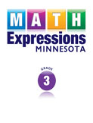
Math Expressions - Crosswalk to the Minnesota Academic Standards in Mathematics, G3
Title
MN-1 Degrees Fahrenheit
MN-2 Degrees Celsius
MN-3 Make a Hundred to Subtract
MN-4 Run a Shop
MN-5 Use the Counting On Strategy

